

**Basic Laboratory Course**

**(Protocol)**

Conservation of Momentum and Energy / Law of Collisions

15th of December 2015

Amrit Lamichhane Alexander Riedl

Group 4, Team 3

## Introduction

Conservation of momentum and energy are to be observed in the experiments to follow.

## Measurement of Velocities on the Basis of Momentum Conservation

Text

## Oblique Elastic Collisions on an Air Cushion Table

To observe oblique elastic collisions und the influence of magnetic interaction forces in this experiment, two pucks with the same polarity are being slid on a cushion table with negligibly tension. In order to prevent the pucks touching each other, both pucks are magnetic with the same polarity, so that both pucks repel each other. Both pucks are being slid forward in an angle towards each other, so that they would collide, but because of their magnetic polarity, the actual collision is prevented. After the virtually collision, both pucks continue their way in an angle depending on how they virtually collided.

To be able to capture the movement in a picture, the whole experiment is illuminated with a stroboscope lamp, which flashes in frequency of *f* = 5,435 Hz or periodic time *T* = 0,184 s for every position of the pucks is clearly distinguishable. The picture is taken with a digital camera using manual exposure for as long as both pucks are sliding towards the end of the cushion table.

The masses of the used pucks are for the black one *mpb* = 227,38 g and for the red one *mpr* = 215,43 g. Both pucks have the same diameter of *dpt* = 8,905 cm or *dps* = 62 pixel, which is determined using the free and open source image processing program GIMP[1].

Due to lack of space, the pictures have been taken using a mirror, therefor the pictures are being equalised using a MATLAB script prior performing further evaluation. Figure 1 shows the important part from the equalised picture with slightly better contrast:

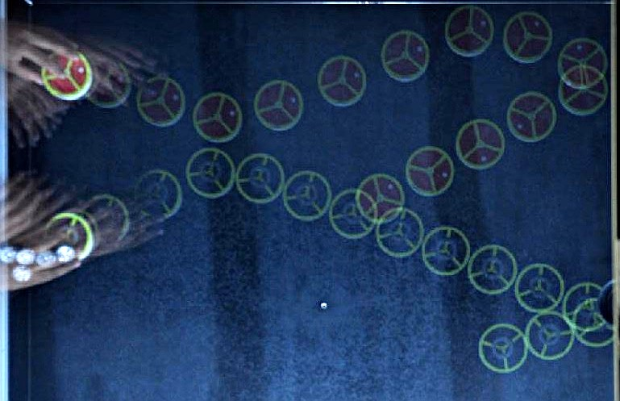

Figure 2: Equalised picture of the experiment showing both pucks in their positions

To being able to calculate with “real world units” i.e. meters instead of pixel, the screen coordinates are being converted into table coordinates using the formula

$M=\frac{image size}{object size}, \left[M\right]=\frac{62}{0,08905}\frac{Pixel}{m}$ ( 1 )

Therefor, the exact *x/y* coordinates of the different positions of both pucks are being determined using GIMP again.

Using a MATLAB script, which can be found in the appendix, the momentum vectors before the collision are determined as

$$momentum vector upper red puck1= \begin{matrix}0,0258 \\ 0,0080\end{matrix}kg m s^{-1}$$

$$momentum vector lower black puck1= \begin{matrix}0,0268 \\ -0,0112\end{matrix}kg m s^{-1}$$

which gives a total momentum of

$$total momentum vector befor collision p1= \begin{matrix}0,0526 \\ 0,0032\end{matrix}kg m s^{-1}$$

The momentum vectors after the collision are

$$momentum vector upper red puck2= \begin{matrix}0,0292 \\ -0,0061\end{matrix}kg m s^{-1}$$

$$momentum vector lower black puck2= \begin{matrix}0,0244 \\ 0,0028\end{matrix}kg m s^{-1}$$

leading to a total momentum of

$$total momentum vector after collision p2= \begin{matrix}0,0536 \\ -0,0033\end{matrix}kg m s^{-1}$$

The momentum difference ∆*p* is to be zero, but it is actually

$$∆p= \begin{matrix}0,0010 \\ -0,0001\end{matrix}kg m s^{-1}$$

which may be the result of the manual determination of exact centres of the puck in a quite grainy picture.

Figure x shows the corresponding momentum vectors including their sums, created with the same MATLAB script:

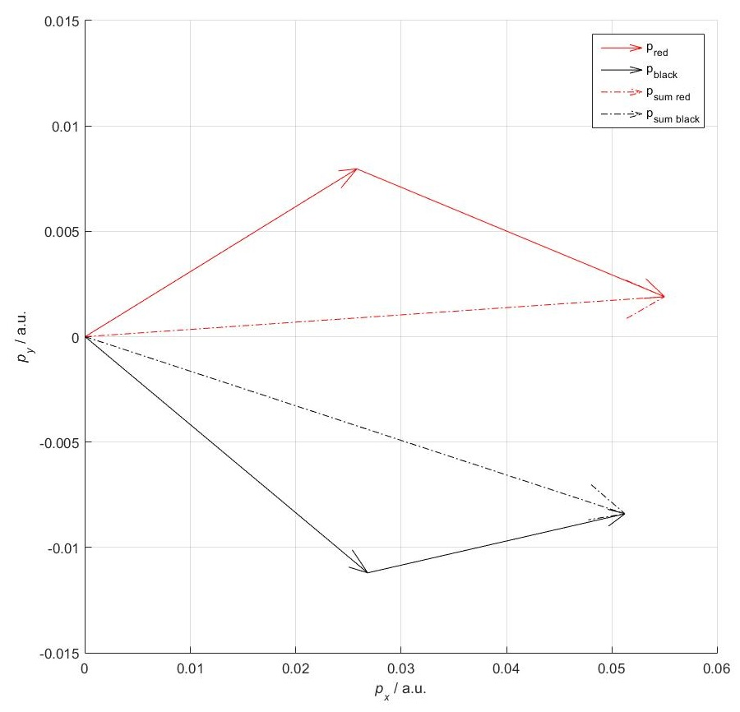

Figure 3: Impulse vectors of both pucks and their sums

The momentum conservation law is almost fulfilled, as mentioned earlier, ∆*p* is only roughly zero arising from measuring inaccuracy.

## Appendix

### MATLAB Script for Determining Vectors and Plotting

clear

close('all','hidden')

%stroboscope

T=1/5.435;

%no of flashes

n=1;

%mass puck black

mpb=0.22738;

%mass puck red

mpr=0.21543;

%magnification

M=62/0.08905;

%positions before collision

xr1=201;

yr1=124;

xb1=194;

yb1=241;

%positions during collision

xr2=269;

yr2=145;

xb2=261;

yb2=213;

%positions after collision

xr3=346;

yr3=129;

xb3=322;

yb3=220;

%position vector puck black before collision

pb1=[xb1;yb1]/M

pb2=[xb2;yb2]/M

%position vector puck red before collision

pr1=[xr1;yr1]/M

pr2=[xr2;yr2]/M

%momentum vector puck black before collision

mb1=mpb*(pb2-pb1)/(n-T)

%momentum vector puck red before collision

mr1=mpr*(pr2-pr1)/(n-T)

%total momentum before collision

tm1=mb1+mr1

%position vector puck black after collision

pb3=[xb3;yb3]/M

%position vector puck red after collision

pr3=[xr3;yr3]/M

%momentum vector puck black after collision

mb2=mpb*(pb3-pb2)/(n-T)

%momentum vector puck red after collision

mr2=mpr*(pr3-pr2)/(n-T)

%total momentum after collision

tm2=mb2+mr2

%difference of momentum

delta_m=tm1-tm2

%plotting

figure

axis([-0 0.06 -0.015 0.015]); axis square

grid on

hold on

%no scaling

s=0;

%momentum vectors before collision red

l1=quiver(0,0,mr1(1),mr1(2),s,'r')

%momentum vectors before collision black

l2=quiver(0,0,mb1(1),mb1(2),s,'k')

%momentum vectors after collision red

l3=quiver(mr1(1),mr1(2),mr2(1),mr2(2),s,'r')

%momentum vectors after collision black

l4=quiver(mb1(1),mb1(2),mb2(1),mb2(2),s,'k')

%sum of momentum vectors red

smr=mr1+mr2;

l5=quiver(0,0,smr(1),smr(2),s,'-.r')

%sum of momentum vectors red

smb=mb1+mb2;

l6=quiver(0,0,smb(1),smb(2),s,'-.k')

%lables and legend

xlabel('{\itp_x} / a.u.');

ylabel('{\itp_y} / a.u.');

legend([l1 l2 l5 l6],{'{p}_r_e_d','{p}_b_l_a_c_k','{p}_s_u_m_ _r_e_d','{p}_s_u_m_ _b_l_a_c_k'})

hold off

1. https://www.gimp.org